What drives petroleum product prices: Production

Refineries produce a wide range of petroleum products when processing crude oil. More complex refineries can upgrade some of the volume of heavier or lower-quality streams into more valuable products such as gasoline (most produced) or distillate(second most produced). Some refineries also have a degree of flexibility with respect to the volume of gasoline versus distillate produced. Price signals can influence short-term production decisions as well as long-term investments that may influence the type of petroleum product produced. Total production of refinery products increased starting in 2013 as U.S. refineries process more crude oil, invest in additional processing units to upgrade products, and expand into international markets. The net increase in production has been driven by large increases in motor gasoline and distillate, despite decreases in products such as residual fuel oil.

Stagnant, slight decrease in gasoline output

Stagnant, slight decrease in gasoline output

What drives petroleum product prices: Consumption

Countries outside of the Organization for Economic Cooperation and Development (OECD) drove increases in global demand for petroleum products in recent years. In aggregate, non-OECD countries consumed more petroleum products than OECD countries for the first time in 2014. Global distillate consumption tends to rise as developing countries show robust economic growth because their economies tend to be driven by industry and manufacturing rather than services. Distillate consumption can slow if economic growth expectations decline or as more countries move towards a more services-oriented economy. As many non-OECD countries continue to develop, their economies tend to be driven by industry rather than services. This trend has led to an increase in global distillate demand.

Gasoline is the most consumed petroleum product in the United States and is used primarily as a transportation fuel. Gasoline consumption is affected by a variety of factors including gasoline prices, disposable income, employment, weather, vehicle miles traveled, as well as regulations on fuel economy.

Distillate is the second-most consumed petroleum product in the United States. In addition to its use as a transportation fuel, distillate is also consumed for heating and power generation purposes. Distillate's use as a heating fuel drives the seasonal pattern of higher consumption during the winter months. Distillate consumption is affected by economic growth and weather conditions as well as vehicle efficiency and miles traveled of heavy-duty vehicles.

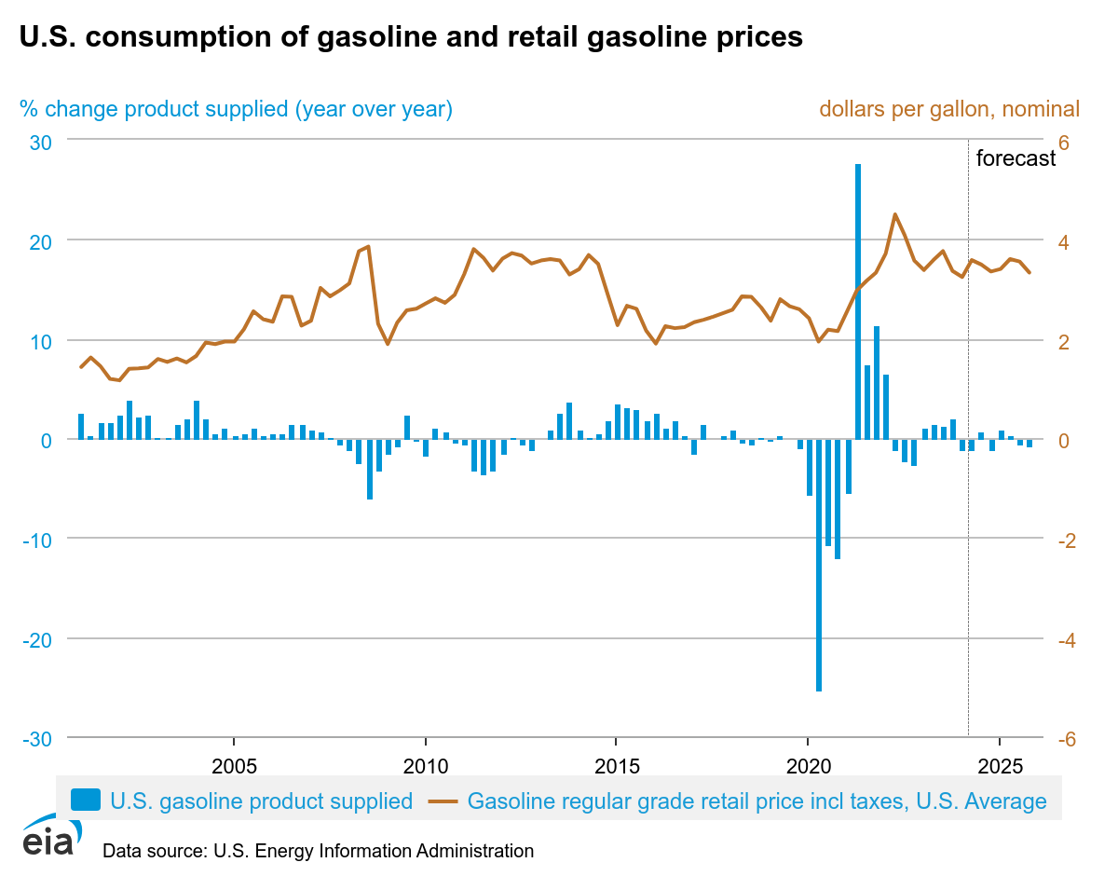

From the graphs gasoline is about the same consumption in the future and diesel consumption bout to increase in the future.

In addition to trading physical quantities of petroleum products, market participants can also use futures contracts to buy or sell gasoline and distillate for future delivery, or to hedge or speculate on future price movements. Since 2006, the underlying commodity for the gasoline futures contract has been reformulated blendstock for oxygenate blending (RBOB), the petroleum component of gasoline in many areas of the country prior to the addition of ethanol to produce finished gasoline.

Since the spring of 2013, the underlying commodity for the distillate futures contract has been ultra-low sulfur diesel (ULSD), a distillate with sulfur content of less than 15 parts per million (ppm). Prior to this change, the underlying commodity for the distillate futures contract was allowed to have sulfur content up to 2,000 ppm, reflecting the type of distillate commonly used for home heating purposes.

Definition: The crack spread is the difference between the cost of crude oil and the market price of petroleum products obtained from it (gasoline if 1:1 and if 3:2:1 then gasonline x 2 diesel x 1 in 3 barrels.

It indicates the refining margin or the potential profitability of refining crude oil. A higher crack spread suggests that refineries can make more profit from refining. If a refiner expects the crack spread to widen, they might hedge by buying crude oil futures and selling refined product futures. If there's a high demand for gasoline but limited refining capacity, the crack spread for gasoline may widen.

During the summer months, the underlying commodity of the RBOB front month contract is required to be gasoline with a lower [Reid vapor pressure](http://www.eia.gov/todayinenergy/detail.cfm?id=11031) (RVP) specification, a more expensive type of gasoline to refine. Starting March 1, RBOB futures prices tend to increase several cents from February averages to reflect the higher valued commodity. This, in turn, is reflected in a higher crack spread. On September 1, the underlying commodity of the RBOB front month contract reverts back to a higher RVP specification, representing a lower-cost gasoline. The gasoline crack spread declines to reflect the lower price of gasoline.

Summer is the driving season resulting in higher domestic demand for gasoline.

As domestic gasoline consumption declines during the winter months, distillate consumption historically rises as consumers in the United States, particularly in the U.S. northeast, use distillate for heating purposes. With the increased demand, distillate crack spreads are usually highest from October to February. distillate is increasingly used as a low-sulfur transportation fuel

The seasonal consumption pattern of gasoline, with higher demand in the summer than in the winter, affects inventory management by refiners and end users. In the summer driving season, gasoline inventories tend to decline whereas in the fall and winter, gasoline inventories are replenished. Distillate inventories also exhibit seasonality based on distillate's use as a heating fuel in the winter months, although this effect has declined in recent years as distillate is increasingly used as a low-sulfur transportation fuel. In areas of the United States, such as the Northeast, where distillate is still widely used for heating, inventories display a more pronounced seasonal pattern of decreasing in the winter time and increasing in the summer.

Because inventories can satisfy either current or future demand, their level is sensitive to the relationship between the current product prices and expectations of future prices. If market expectations indicate a change toward relatively stronger future demand or lower future supply, prices for futures contracts will tend to increase, encouraging inventory builds to satisfy the otherwise tightening future balance. On the other hand, a sharp loss of current production or unexpected increase in current consumption will tend to push up spot prices relative to futures prices and encourage inventory drawdowns to meet the current demand. The futures curve for gasoline, for example, exhibits the seasonality inherent to the product's consumption. Prices for summer months are higher, which encourages inventory builds in the transition months between seasons to satisfy future demand.

What drives petroleum product prices: Trade

With [significant increases in U.S. crude oil production](http://www.eia.gov/todayinenergy/detail.cfm?id=20572) and higher refinery runs, increased production of petroleum products reduced the reliance on oil imports to meet domestic demand. In the fourth quarter of 2012, the United States became a net exporter of gasoline after historically being a net importer. Since then, the United States has often been a net exporter of gasoline during the winter months. [PADD](http://www.eia.gov/todayinenergy/detail.cfm?id=4890) 3 has consistently been a net exporter of gasoline since the third quarter of 2009. However, PADD 1 remains a net importer because of transportation constraints in moving petroleum products from the U.S. Gulf Coast to the U.S East Coast.